J2 Manual Drill
a) ( 0x4002 0000 - 0x4002 03FF) This is the boundary address for the GPIOA got from the document Datasheet of STM32. Picture given below
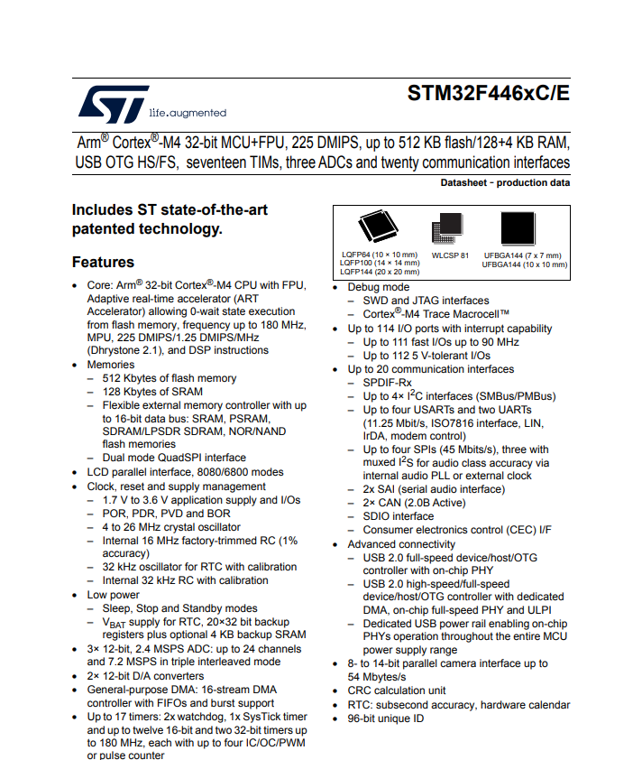
b) The GREEN Led is the user LED and is on D13 Pin. For USART wiring to the ST-LINK virtual COM port , PA2 and PA3 are responsible. (From section 7.6 and section 7.10 respectively in UM1724)
c)
d) there are two advanced control timers TIM1 and TIM8
They have complementary PWM outputs with programmable inserted dead timers and they can also be considered as GPIO. (in section 3.21.1 and in the datasheet of STM32)

